Directions
Public transportation:
From Manhattan: Take the 6 train (green line) Uptown to Westchester Square Station and change to the Bx40 bus. Our campus is the last stop. Further information, including schedules, can be found at the MTA website.
The MTA offers express bus service between Manhattan and Throgs Neck. The BxM9, a second option, is an express bus costing $5.50 each way, and its bus stop is at the intersection of Pennyfield Avenue and Harding Avenue. Additional information, including schedules, are at http://www.mta.info/busco/schedules/bxm9cur.pdf.
The Maritime College is easily accessible by car as follows:
From Brooklyn or Queens: Via the Whitestone Bridge: Pay toll at extreme right booth, take immediate right exit to traffic light, turn right to next traffic light, turn right then left onto I-295. Keep to right and take EXIT 9 (Harding Ave/Fort Schuyler) just before Throgs Neck Bridge. At EXIT 9 (Harding Ave/Fort Schuyler) take left fork, then make immediate right on to Harding Avenue. Proceed along Harding Avenue to stop sign. Turn left on Pennyfield Avenue to Maritime College gatehouse.
From Manhattan (East Side): North on East River Drive (FDR Drive) to either:
(a) Willis Avenue Bridge (no toll) then keep right to Bruckner Blvd. to ramp leading to I-278 Bruckner Expressway, then follow Throgs Neck Bridge signs to EXIT 9 (Harding Ave/Fort Schuyler) just before bridge. At EXIT 9 (Harding Ave/Fort Schuyler) take left fork, then make immediate right on to Harding Avenue. Proceed along Harding Avenue to stop sign. Turn left on Pennyfield Avenue to Maritime College gatehouse.
(b) Triboro (aka RFK) Bridge (toll) follow "New England" signs to Throgs Neck Bridge signs to EXIT 9 (Harding Ave/Fort Schuyler) just before bridge. At EXIT 9 (Harding Ave/Fort Schuyler) take left fork, then make immediate right on to Harding Avenue. Proceed along Harding Avenue to stop sign. Turn left on Pennyfield Avenue to Maritime College gatehouse.
From Manhattan (West Side):
North on West Side Highway to 178 Street EXIT to I-95 North Cross Bronx Expressway. Follow Throgs Neck Bridge signs to EXIT 9 (Harding Ave/Fort Schuyler) just before bridge. At EXIT 9 (Harding Ave/Fort Schuyler) take left fork, then make immediate right on to Harding Avenue. Proceed along Harding Avenue to stop sign. Turn left on Pennyfield Avenue to Maritime College gatehouse.
From LGA or JFK Airports:
When taking a taxi from LGA or JFK airport, your driver may take either the Whitestone or the Throgs Neck Bridge to the Maritime College campus. The bridges cost the same, and they’re approximately equidistant.
Via the Whitestone Bridge: Pay toll at extreme right booth, take immediate right exit to traffic light. Turn right to next traffic light, turn right then left onto I-295. Keep to right and take EXIT 9 (Harding Ave/Fort Schuyler) just before Throgs Neck Bridge. At EXIT 9 (Harding Ave/Fort Schuyler) go left at stop sign at end of exit ramp, then make immediate right on to Harding Avenue. At stop sign, turn left onto Pennyfield Avenue, and proceed to the end until you reach the Maritime College gatehouse.
OR
Via the Throgs Neck Bridge: Pay toll at extreme right booth, take immediate exit for Pennyfield Avenue-Fort Schuyler. Proceed along service road to 2nd stop sign (2 blocks). Make left onto overpass. At light, veer left onto Pennyfield Avenue, proceed to the end until you reach the Maritime College gatehouse.
From New Jersey Via George Washington Bridge:
Garden State or N.J. Turnpike to New York and I-95 North, then follow signs to Throgs Neck Bridge to EXIT 9 (Harding Ave/Fort Schuyler) before bridge. At EXIT 9 (Harding Ave/Fort Schuyler) take left fork, then make immediate right on to Harding Avenue. Proceed along Harding Avenue to stop sign. Turn left on Pennyfield Avenue to Maritime College gatehouse.
From Upper New York State:
1. Palisades Parkway South to George Washington Bridge, I-95 North, then follow 295 South to Throgs Neck Bridge and take EXIT 9 (Harding Ave/Fort Schuyler) just before bridge. At EXIT 9 (Harding Ave/Fort Schuyler) take left fork, then make immediate right on to Harding Avenue. Proceed along Harding Avenue to stop sign. Turn left on Pennyfield Avenue to Maritime College gatehouse.
2. Tappan Zee Bridge, south on I-87 to I-95 North. Follow 295 South to Throgs Neck Bridge and take EXIT 9 (Harding Ave/Fort Schuyler) just before bridge. At EXIT 9 (Harding Ave/Fort Schuyler) take left fork, then make immediate right on to Harding Avenue. Proceed along Harding Avenue to stop sign. Turn left on Pennyfield Avenue to Maritime College gatehouse.
3. Tappan Zee Bridge, follow I-287, then South on Sprain Brook Parkway and Bronx River Parkway to I-95 North. Follow 295 South to Throgs Neck Bridge and take EXIT 9 (Harding Ave/Fort Schuyler) just before bridge. At EXIT 9 (Harding Ave/Fort Schuyler) take left fork, then make immediate right on to Harding Avenue. Proceed along Harding Avenue to stop sign. Turn left on Pennyfield Avenue to Maritime College gatehouse.
4. Hutchinson River Parkway South to Bruckner Expressway Exit, I-95 South, (sharp right after overpass) then follow 295 South to Throgs Neck Bridge and take EXIT 9 (Harding Ave/Fort Schuyler) on right just before bridge. Caution: You must cross three lanes in 300 yards. At EXIT 9 (Harding Ave/Fort Schuyler) take left fork, then make immediate right on to Harding Avenue. Proceed along Harding Avenue to stop sign. Turn left on Pennyfield Avenue to Maritime College gatehouse.
5. From New England and New England Thruway I-95 South to the Bronx, then follow 295 South to Throgs Neck Bridge and take EXIT 9 (Harding Ave/Fort Schuyler) on right just before bridge. Caution: You must cross three lanes in 300 yards. At EXIT 9 (Harding Ave/Fort Schuyler) take left fork, then make immediate right on to Harding Avenue. Proceed along Harding Avenue to stop sign. Turn left on Pennyfield Avenue to Maritime College gatehouse.
From Long Island and Long Island Expressway:
I-495 West on Long Island Expressway to either Cross Island Parkway or Clearview Expressway to I-295 North to Throgs Neck Bridge; take Pennyfield Avenue-Fort Schuyler exit immediately after far-right toll station. Proceed along service road to 2nd stop sign (2 blocks). Make left on to overpass to Pennyfield Avenue to Maritime College gatehouse.
Once on Campus:
Follow the main campus road until you arrive at the Riesenberg Gymnasium Parking Lot (see below). Our offices are located on the first floor in the Marvin-Tode Hall (Science/Engineering) Building. After entering the building, take the first right and proceed through the double glass doors to the left of the elevator.
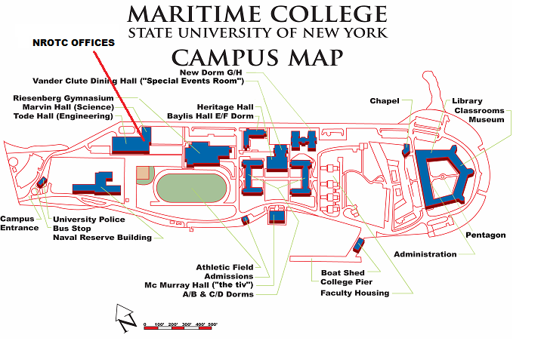
Mailing Address
Commanding Officer
NROTC Unit
SUNY Maritime College
6 Pennyfield Avenue
Bronx, NY 10465-4198

Administration
718.409.7269
718.409.7402 (fax)

email the Recruiting Officer

