

UNIFORM REGULATIONS

FOR THE REGIMENT OF CADETS

**This manual is current as of February 2015. Cadets are advised that the information contained in this manual is subject to change at the discretion of the Commandant of Cadet's office. The Commandant reserves the right to add, repeal, or amend any uniform or grooming standard affecting cadets. When/If this occurs, the Commandant's Office will provide appropriate notice as is reasonable under the circumstances. All cadets are expected to have knowledge and understanding of the information contained in this regulation and in other publications as they are referenced. Matriculation at this college (and into the Regiment of Cadets) constitutes the cadet's agreement to the uniform and grooming standards outlined in this document.**

**STATE UNIVERSITY OF NEW YORK**

**MARITIME COLLEGE**

**UNIFORM REGULATIONS**

**Table of Contents**

|  |  |  |  |  |
| --- | --- | --- | --- | --- |
| **CHAPTER ONE - GENERAL UNIFORM REGULATIONS** | | | | |
|  |  | | **Article** | |
| **SECTION 1**  1. | **GENERAL INFORMATION**  POLICY | | | 1101  1101.1 |
| 2. | HISTORY | | | 1101.2 |
| 3.  **SECTION 2** | GENERAL  **UNIFORM STANDARDS** | | | 1101.3  1201 |
| 1. | MANNER OF WEAR | | | 1201.1 |
| 2. | OVERGARMENTS | | | 1201.2 |
| 3. | BOILERSUIT | | | 1201.3 |
|  |  | | |  |
| **CHAPTER TWO - GROOMING STANDARDS** | | | | |
|  |  | | |  |
| **SECTION 1**  1. | **GENERAL INFORMATION**  POLICY | | | 2101  2101.1 |
| **SECTION 2**  1.  2. | **GROOMING STANDARDS**  MALE SPECIFIC  FEMALE SPECIFIC | | | 2201  2201.1  2201.2 |
|  |  | | |  |
|  |  | | |  |
|  |  | | |  |
|  |  | | |  |
|  |  | | |  |
| **CHAPTER THREE - UNIFORM COMPONENTS** | | | | |
|  |  | | |  |
|  | |
| **SECTION 1**  1.  2. | **UNIFORM COMPONENTS**  UNIFORM COMPONENTS  MISCELLANEOUS | | | 3101  3101.1  3101.2 |
| **CHAPTER FOUR - RANK/RATE INSIGNIA** | | | | |
|  |  | | |  |
|  | |
| **SECTION 1**  1. | **GENERAL INFORMATION**  POLICY | | | 4101  4101.1 |
| **SECTION 2**  1.  2.  3.  4. | **INSIGNIA**  BAND AND HONOR GUARD  BREAST INSIGNIA  COLLAR, CAP, AND RANK INSIGNIA  RIBBONS | | | 4201  4201.1  4201.2  4201.3  4201.4 |
| **CHAPTER FIVE – CUSTGOMS AND COURTESIES** | | | | |
|  | |
|  |  | | | |
| **SECTION 1**  1. | **GENERAL INFORMATION**  POLICY | | | 5101  5101.1 |
| **SECTION 2**  1.  2.  3.  4. | **MILITARY COURTESIES**  GENERAL  SALUTING  SHIPBOARD PROTOCOL  COLORS AND NATIONAL ANTHEM | | | 5201  5201.1  5201.2  5201.3  5201.4 |

**CHAPTER 6 – UNIFORM MAINTENANCE, CARE AND MARKING**

|  |  |  |  |  |  |
| --- | --- | --- | --- | --- | --- |
|  |  | | |  | |
|  |  | |  |
| **SECTION 1**  **SECTION 2**  **SECTION 3**  **SECTION 4** | | **GENERAL MAINTENANCE**  **CARE OF UNIFORMS**  **MARKING OF CLOTHING**  **CIVILIAN CLOTHING** | | | **6101**  **6201**  **6301**  **6401** | |

**CHAPTER 1 – GENERAL UNIFORM REGULATIONS**

|  |  |  |
| --- | --- | --- |
| **SECTION 1:** | **GENERAL INFORMATION** | **Article**  **1101** |
| **1.** | **POLICY** | **1101.1** |
| **2.** | **HISTORY** | **1101.2** |
| **3.** | **GENERAL** | **1101.3** |
| **SECTION 2:**  **1.** | **UNIFORM STANDARDS**  **MANNER OF WEAR** | **1201**  **1201.1** |
| **2.** | **OVERGARMENTS** | **1201.2** |
| **3.** | **BOILERSUIT** | **1201.3** |

1101. GENERAL INFORMATION

1. POLICY

This document will set a standard for uniform and grooming for the Regiment of Cadets. Changes to the standards can occur at any time. No one, regardless of position, rank or title may excuse or change these requirements except for the Commandant and Deputy Commandant of Cadets; such changes will be communicated through official channels.

1. HISTORY

The uniforms worn at Maritime College draws its origins from the United States Navy; the only difference typically being the insignia on the collar or on the sleeve, and the buttons on the Pea Coat and Service Dress Blue Jacket, which say “USMS” (standing for United States Maritime Service).

3. GENERAL

1. The wearing of the uniform is a matter of personal pride to us all. Cadets shall wear their uniform with respect, as they are all direct representatives of the College. This is especially true during Summer Sea Term while visiting foreign countries where dress and conduct not only reflect credit/discredit on the individual Cadet, but on the College and the United States as well. In addition to the uniform representing the embodiment of the Regiment, it is also important in maintaining the security of the campus. All Cadet are responsible for maintaining a full seabag compliment of uniforms, rates, and issued items.
2. Uniforms will be worn in a military manner at all times. While in uniform, Cadets are a very visible representative of the Regiment and the College, and provide an impression of these that can be long lasting. As such, while in uniform, all outer garments and shirts will be fully buttoned and caps and hats will be worn squarely on the head at all times and spaced no more than two fingers above the nose; no hair should protrude from the front of the cover (for males or females). The khaki cover brim should be kept dust and fingerprint free, use a soft cloth to buff out any fingerprints. Buttons securing the gold strap shall be rotated to face upwards. The cap device shall be mounted as per the provided diagram; use a marlin spike to make a hole in the mounting band.
3. The prescribed uniform shall be worn at all times in a strictly military manner. Jackets and overcoats shall be fully buttoned or zipped. Covers shall be worn squarely on the head at all times and spaced no more than two fingers above the nose; no hair should protrude from the front of the cover (for males or females).` Cadets will dress neatly and smartly at all times. Uniforms shall be scrupulously clean. All buttons, snaps, zippers, etc. shall be fastened at all times. This includes the "neck button" on all jackets for 4/C Cadets, and the boilersuit and pocket buttons for all uniforms and classes. Nothing shall be protruding from shirt pockets; all pens and pencils should be stowed completely within. Pants pockets are for stowing necessary items only; they should never be overstuffed. The only time a Cadet should put their hands in their pockets is to retrieve an item; if your hands are cold, wear gloves. Cadets are subject to these regulations at any time while in uniform on college property, the TSES, college sponsored trips and events, or at any other such time that the uniform is worn. Uniform regulations apply while on the TS Empire State regardless of nature of business aboard. Uniforms are to be worn in the prescribed manner regardless of location.
4. The uniform of the day will be prescribed by announcement by the Regimental Adjutant, via e-mail blast, and posted on RegWeb. On most days, the uniform of the day will be “standard issue” (Poly-Wool) Khakis. Seasonal changes of uniform will be announced in advance. Only the uniforms prescribed by the Regimental Commander, or that necessary for special classes or laboratories, shall be worn between 0700 and 1600. While in attendance at evening classes, all Cadets will be in the prescribed khaki uniform. No faculty member is authorized to allow Cadets to be out of uniform at any time while in class. On some days (Admissions Open Houses, Career Fairs, etc.) the uniform of the day will be the in-season dress uniform. All will be required to were the dress uniform on those designated days from 0700 – 1600.
5. After 1600 and on weekends, civilian clothing is authorized. Civilian clothing on the mess deck is only authorized for the evening meal on Fridays and the weekends; Cadets are to be in uniform for all meals on the mess deck from Monday morning (breakfast hours) through Friday afternoon (lunch hours).
6. 4/C Cadets will be in uniform at all times while on campus, except on the weekends. The Chief Indoctrination Officer and RegWeb postings will dictate which uniform is to be worn.
7. 4/C Cadets are authorized to wear Maritime issued PT gear or issued sweat shirt/pants after 1600, unless coming/going from/on liberty. On Friday evenings and during weekend meals 4/C Cadets will dine on the mess deck in the uniform of the day until given permission to wear PT gear by the Chief Indoctrination Duty Officer.
8. While attending classes, or participating in a College-related or sponsored event, while in any official place of business on campus (i. e. the Registrar, Student Accounts, Regimental Assistant), and/or while in the Ship's Store, Cadets are to be in the proper uniform of the day.
9. For security purposes, Maritime ID cards should be carried with you at all times and displayed when requested by higher authority.
10. Uniform components deemed unserviceable will be replaced at the Cadet’s expense.

1201. UNIFORM STANDARDS

1. MANNER OF WEAR

* 1. All classes are to wear the standard issued poly-wool khaki uniform with black leather shoes and garrison cover. Cover, belt, name tag, company pin, class pin, and state seal insignia are to be donned at all times.
  2. Boots are not to be worn with khakis (unless authorized by the Commandant or Deputy Commandant of Cadets through the Regimental Commander).
  3. The webbed/mesh khaki belt can only be worn with the poly-cotton uniform.
  4. Only 1/C Cadets who have completed all three cruises shall be allowed to wear the “TSES” belt buckle, centered on their gig line.
  5. All classes are encouraged to include authorized dress uniform ribbons with their khaki uniform.
  6. The Regimental Commander, Regimental Executive Officer, Regimental Operations Officer, Regimental Adjutant, and Indoctrination Chief Duty Officer are authorized to wear the khaki combination cover.
  7. Uniform articles may not be worn if they are excessively faded, worn, stained (i.e. paint, oil, etc.) or do not fit properly (i.e. do not conform to the body as the uniform is designed too – meaning they are too tight or too big).
  8. All khaki uniforms are required to have all buttons in which they shall be buttoned at all times.
  9. Uniforms must be worn with the appropriate devices or insignia at all times. This includes collar and cover devices, shoulder boards or striping, names, etc. These items must be positioned properly on the uniform.
  10. Shoes must be shined or must not be excessively scuffed or severely cracked (i.e. Corframs ®).
  11. The appropriate color sock is to be worn with the respective uniform. Black dress socks are to be worn with khakis and Dress Blues, white dress socks are to be worn with Dress Whites. Socks must be long enough so only the sock can be seen when sitting in uniform (i.e. leg skin should not be visible when seated in uniform and should be covered by the length of the sock). Any color socks can be worn with the boilersuit.
  12. Both garrison and dress combination covers are to be worn level on the head with absolutely no backward or sideways tilts.
  13. Mobile phones may be used while in uniform, whether standing still or in transit, provided that the use of the phone does not prevent or hinder the user from being able to properly carry out all courtesies and honors (i.e. saluting a senior officer). 4/C Cadets are not authorized to use phones while on the “MUG path.”
  14. At no time may Cadets listen to music players while in uniform. There shall be no headphones or ear buds worn with any uniform (ex: khaki/dress uniform or boilersuit).
  15. Only 1/C Cadets are permitted to wear the issued Maritime College ball cap with school seal while in the khaki uniform. The cap may be tucked in the small of the back between the blouse and the trousers for stowage. 1/C Cadets who have completed all three cruises are authorized to wear the “TSES” ball cap in lieu of the Maritime College ball cap. All caps will be clean, dry, and serviceable, that is, excessive fraying or staining (i.e. paint, bleach) is unauthorized. Caps will be worn squarely on the head with no tilting to the back or sides. No hair shall protrude from underneath the bill of the cap. No ornaments shall be affixed to the cover (i.e. fish hooks). The cap will be worn in a conventional manner such that the bill has a downward curvature; flaring the edge up, maintaining a flat bill, or creating a “funneled” appearance with the bill is unauthorized.
  16. Ties will be kept clean and will be neatly pressed. Male Cadet ties will be tied with a DOUBLE-WINDSOR knot. Female Cadet ties shall be of the CROSS-OVER type.
  17. All uniform coats, shirts, trousers, and skirts shall be neatly pressed and clean. No objects which protrude from or cause excessive bulging of uniform pockets will be carried.
  18. Shoulder boards, complete with appropriate striping and devices, shall be worn with the prescribed uniform at all times. Striping and devices shall be free of frays or tarnish.
  19. Brass belt buckles shall maintain a polished or “high sheen” surface. Belts shall be adjusted in the buckle in such a manner so that the metal end tab just protrudes from the buckle.
  20. Shoes with deep scratches, holes, loose soles, run down heels, etc., shall not be worn. Issued work shoes must be worn with the prescribed work uniform.
      1. OVERGARMENTS

a. The only jackets or overgarments authorized to be worn over khaki uniforms include the following Maritime College apparel:

1. Peacoats.
2. Eisenhower jacket (otherwise known as the “relaxed fit” jacket).
3. Black sweater.
4. No sports or team jackets or what could be otherwise considered recreational overgarments are to be worn with the khaki uniform (unless specifically authorized by the Commandant of Cadets).

b. The only jackets or overgarments authorized for wear with the Maritime boiler suit include:

1. Gray Maritime sweatshirt (of various lettering styles). The hood can only be worn up when designated by the Regimental Commander for inclement weather or when conducting ship work. (Must be worn under the boilersuit.)
2. Black Maritime windbreaker (reversible).

c. Overgarments with center zippers must be zipped to the following regulations:

1. Zipped 3/4 of the way up (1/C, 2/C, 3/C only). 3/4 of the zipper rail is the height approximately parallel to the height of the bottom of the SUNY maritime College logo on the left breast of the jacket.

2. Zipped to the top of the zipper rail. (All 4/C)

d. Overgarments with buttons must have all buttons fastened (with the exception of neck buttons as with the peacoat). The Chief Indoctrination Officer may direct the 4/C to button the neck button as deemed appropriate.

e. Black unmarked wool watch covers may only be worn with the peacoat, boilersuit, or PT gear. The wearing of the wool cover is authorized by the Regimental Commander. The Regimental Commander will make the determination for the need for the wool cap (ex: inclement weather) and announce it in the uniform-of-the-day. Black wool watch covers are authorized between 1 November and 31 March of the academic year.

1. Belts shall be adjusted in a manner such that only the metal tab is visible from the end of the buckle.
2. Black Leather Shoes: Leather shoes are to be highly polished at all times while in uniform. There are a number of different methods to polish shoes which can be found on the internet. One of the easiest ways is to use a soft cloth with Kiwi Black “Parade Gloss” Polish and a few drops of water in a buffing motion to obtain a shine. Applying multiple layers of polish will create a mirror-like shine. “Instant Shine” liquids or similar products will deteriorate the leather over time and should not be used to shine your shoes.
3. Dress Whites Undergarments: Undergarments must be solid white when worn with the Dress Whites, any other colors or patterns will show through the uniform.
4. Combination Cover: The brim of male covers should be kept dust and fingerprint free, use a soft cloth to buff out any fingerprints. Buttons securing the gold strap shall be rotated to face upwards. The cap device shall be mounted as per the provided diagram, use a marlin spike to make a hole in the mounting band.
5. Black Sweater: The sweater can be worn underneath the black “relaxed fit” (Eisenhower) jacket, the peacoat, and the service dress blues jacket. The collars of the khaki blouse will be worn out of the sweater top so as to lay flat on the sweater and show both collar devices. Name tape and company pin will be worn on the right breast in the same fashion and placement as on the khaki blouse.
6. BOILERSUIT
7. The official work uniform for Cadets in the Regiment is the boilersuit. The work uniform is not to be worn in the fort area, the dining hall (Mess Deck), or any other areas except in conjunction with extra duty or work programs aboard the Training Ship. The boilersuit is never to be worn while conducting administrative business (i.e. the registrar office, Ship’s Store). The boilersuit may be worn to labs in the S & E Building. The boilersuit may be worn to the eateries The Bottom Line and the S&E building to purchase and eat food. Only steeled-toed black work boots are to be worn while in boilersuits. Unless engaged in physical labor, the zipper is to be zipped to the top, sleeves are to be rolled down, and the pants are to be placed over the boot. The boilersuit is a uniform and Cadets will wear the appropriate head gear and will render salutes in accordance with this policy.
8. Boilersuit Sewing: Patches are to be secured to the boilersuit according to the diagram provided. Stitching is to be done neatly in thread that matches the patch being sewn. Machine stitching is the preferred method, although neat hand-stitching is acceptable.
9. All boilersuits are to have stitched to them the Cadet’s name, Maritime College insignia, and name stenciled on the back. 1/C Cadets are authorized to wear an “American Flag” patch on the right shoulder and one (1) additional patch of their choice (optional) on the left shoulder. The personal patch shall not be offensive, vulgar, or in any way bring discredit upon the College.
10. Any boilersuit that is ripped or torn may not be worn until fixed with proper stitching. Additionally, any boilersuit that contains inappropriate drawings, excessive paint, bleach, or stains shall be discarded immediately and a new one to be donned.
11. Steel-toed black boots are the only authorized footwear to be worn with the boilersuit. Boots are to be laced to the top and tied correctly.
12. 4/C Cadets must wear the Maritime issued blue bump-cover. All other Cadets authorized to wear the ball cap are only permitted to wear the issued Maritime College cap with school seal image.
13. 1/C Cadets are required to wear a grey boilersuit. 2/C, 3/C, and 4/C Cadets will wear a Navy blue or tan boilersuit, depending on the rotating color/class schedule.
14. Under no conditions may uniform shirt sleeves be rolled up (unless otherwise designated by competent authority). Shirt sleeves will be rolled down during formations, and safety and security drills.

**CHAPTER 2 – GROOMING STANDARDS**

|  |  |  |
| --- | --- | --- |
| **SECTION 1:** | **GENERAL INFORMATION** | **Article**  **2101** |
| **1.** | **POLICY** | **2101.1** |
| **SECTION 2:**  **1.** | **GROOMING STANDARDS**  **MALE SPECIFIC** | **2201**  **2201.1** |
| **2.** | **FEMALE SPECIFIC** | **2201.2** |

2101. GENERAL INFORMATION

1. POLICY
2. The primary consideration is to have a neatly groomed appearance while wearing uniforms. Grooming standards are based on several elements including neatness, cleanliness, safety, professional image and appearance. The standards established here are not intended to be overly restrictive nor are they designed to isolate the Maritime Cadet from society. The limits set forth are reasonable, enforceable, and insure that personal appearance contributes to a favorable image. The difference between men's and women's grooming policies recognizes the difference between the sexes; sideburns for men, different hairstyles and cosmetics for women. Establishing identical grooming and personal appearance standards for men and women would not be in SUNY Maritime’s best interest and is not a factor in the assurance of equal opportunity. Because it is impossible to provide examples of every appropriate or unacceptable hairstyle of "conservative" or "eccentric" grooming, the good judgment of leaders at all levels are key to enforcement of grooming policy. Therefore, hair/grooming standards while in uniform shall present a neat, professional appearance.
3. It is the responsibility of each individual Cadet to ensure that his/her grooming conforms to the standards prescribed by the College for the Regiment of Cadets. Lasting impressions are based on first appearances, and it should be the goal of every Cadet to always present a sharp and squared away appearance.
4. Shaves are required every morning and prior to any formal regimental function including inspections for male Cadets. There must be no facial growth visible in order to pass an inspection. This requirement is included for all classes, final exams, watches, and official college functions.
5. Haircuts must be within regulations at all times. All permitted hair styles must be kept in a neat and professional appearance. Faddish haircuts or hair styles, to include color dyes, that do not conform to a professional or neat appearance are prohibited.
6. Medical conditions that prevent a cadet from adhering to the published grooming standards must be fully documented in your medical record in Health Services - to include a diagnosis, prognosis and treatment plan from a medical professional certified in the medical specialty for your condition. If warranted, a chit will be issued by Health Services documenting the condition, the required treatment, and an expiration date for when the condition can reasonably be resolved and the cadet can return to proper grooming standards. Prolonged or incurable conditions may require review by a medical suitability board for continued participation in the Regimental/license program.

2201. GROOMING STANDARDS

1. MALE SPECIFIC GROOMING STANDARDS
2. Facial hair: The face shall be clean shaven unless a shaving waiver is authorized by the Deputy Commandant of Cadets for medical reasons. Shaving will occur each weekday morning before formation so as to be inspection ready. Mustaches are authorized for 1/C Cadets, but shall be kept neatly and closely trimmed. No portion of the mustache shall extend below the lip line of the upper lip. It shall not go beyond a horizontal line extending across the corners of the mouth and no more than 1/4 inch beyond a vertical line drawn from the corner of the mouth.

The length of an individual mustache hair fully extended shall not exceed approximately 1/2 inch. Handlebar mustaches, goatees, beards or eccentricities are not permitted. If a shaving waiver is authorized, no facial/neck hair shall be shaved, manicured, styled or outlined nor exceed 1/4 inch in length. Supervisors of individuals with shaving waivers shall actively monitor and ensure treatment regimen is followed.

1. Sideburns: Sideburns shall not extend below the center of the ear opening. Eccentric sideburn styles, (e.g. mutton chop, ice picks) are not authorized. Sideburns shall be evenly graduated to conform to the taper of the hair as outlined in hair grooming, and shall be of even width (not flared), ending with a clean shaven horizontal line.
2. Hair: Keep hair neat, clean and well groomed. Hair above the ears and around the neck shall be tapered from the lower natural hairline upwards at least 3/4 inch and outward not greater than 3/4 inch to blend with hairstyle. Hair on the back of the neck must not touch the collar. Hair shall be no longer than four inches and may not touch the ears, collar, extend below eyebrows when headgear is removed, show under front edge of headgear, or interfere with properly wearing headgear. The bulk of the hair shall not exceed approximately two inches. Bulk is defined as the distance that the mass of hair protrudes from the scalp. Hair coloring must look natural and complement the individual. Faddish styles and outrageous multicolored hair are not authorized. The unique quality and texture of curled, kinked, waved, and straight hair are recognized, and in some cases the 3/4 inch taper at the back of the neck may be difficult to attain. In those cases hair must present a graduated appearance and may combine the taper with a line at the back of the neck. One (cut, clipped or shaved) natural, narrow, fore and aft part is authorized. Varying hairstyles, including afro, are permitted if these styles meet the criteria of maximum length and bulk, tapered neck and sides, and do not interfere with properly wearing headgear. Plaited or braided hair shall not be worn while in uniform or in a duty status.
3. Hair pieces: Wigs or hair pieces may be worn by Cadets only for cosmetic reasons to cover natural baldness or physical disfiguration. Wigs or hair pieces will be of good quality and fit, present a natural appearance and conform to the grooming standards set forth in these regulations. They will not interfere with the proper performance of duty, or present a safety hazard.
4. Fingernails: Fingernails shall be kept clean and shall not extend past the fingertip.
5. Jewelry: The following items of jewelry are authorized for male Cadets. Jewelry shall not present a safety hazard and shall be worn within the following guidelines:
6. Earrings: Earrings are not authorized and will not be worn at any time, place, or event while in uniform. Additionally, no article shall be attached to or through the nose, tongue, or any other visible part of the body while in uniform. Spacers and/or retainers associated with gauging, or covering of unauthorized earrings (ex: adhesive bandages) is prohibited.
7. Necklaces/chokers: While in uniform, only one necklace may be worn, and it shall not be visible. Necklaces must be made of silver or gold. One religious ornament per necklace is authorized.
8. Rings: While in uniform, only one ring per hand is authorized, excluding the wedding ring.
9. Wristwatch/bracelets: While in uniform, only one wristwatch and one bracelet may be worn. Watches shall be black, brown, tan, navy blue, olive drab green, metallic, silver or metallic gold. Bracelets shall be metal, not plastic, rope, or mesh, and will be free of charms. Ankle bracelets are not authorized while in uniform.
10. FEMALE SPECIFIC GROOMING STANDARDS
11. Hair: Hairstyles shall not be outrageously multicolored or faddish, to include shaved portions of the scalp (other than the neckline), or have designs cut or braided into the hair. Hair coloring must look natural and complement the individual. Haircuts and styles shall present a balanced appearance. Lopsided and extremely asymmetrical styles are not authorized. Ponytails, pigtails, widely spaced individual hanging locks, and braids which protrude from the head, are not authorized. Multiple braids are authorized. Braided hairstyles shall be conservative and conform to the guidelines listed herein. When a hairstyle of multiple braids is worn, braids shall be of uniform dimension, small in diameter (approx. 1/4 inch), and tightly interwoven to present a neat, professional, well groomed appearance. Foreign material (i.e., beads, decorative items) shall not be braided into the hair. Short hair may be braided in symmetrical fore and aft rows (corn rowing) which minimize scalp exposure. Corn row ends shall not protrude from the head, and shall be secured only with inconspicuous rubber bands that match the color of the hair. Appropriateness of a hairstyle shall also be judged by its appearance when headgear is worn. All headgear shall fit snugly and comfortably around the largest part of the head without distortion or excessive gaps. Hair shall not show from under the front of the brim of the combination hat, garrison, or school ball caps. Hairstyles which do not allow headgear to be worn in this manner, or which interfere with the proper wear of protective masks or equipment are prohibited. When in uniform, the hair may touch, but not fall below a horizontal line level with the lower edge of the back of the collar. Long hair, including braids, which fall below the lower edge of the collar shall be neatly and inconspicuously fastened, pinned, or secured to the head. No portion of the bulk of the hair as measured from the scalp will exceed approximately 2 inches.
12. Female Cadets are to wear their hair in the appropriate and tight bun at all times when in uniform. 1/C Cadets are authorized to French-braid their hair in lieu of a bun, however, it will comply with existing grooming standards, that is, the end of the braid may not fall below the lower edge of the back of the collar and shall be inconspicuously fastened, pinned or secured to the back of the head.
13. Hair ornaments: A maximum of two small barrettes/combs/clips, similar to hair color, may be used in the hair. Additional bobby pins or rubber bands matching hair color may be used to hold hair in place, if necessary. Fabric elastics bands are not authorized. Hair ornaments shall not present a safety or FOD (Foreign Object Damage) hazard. Hair nets shall not be worn unless authorized for a specific type of duty.
14. Hair pieces: Hair pieces or wigs worn while in uniform shall be of good quality and fit, present a natural appearance, and conform to the grooming standards set forth in these regulations. They shall not interfere with the proper performance of duty, or present a safety hazard.
15. Cosmetics: Cosmetics may be applied in good taste so that colors blend with natural skin tone and enhance natural features. Exaggerated or faddish cosmetic styles are not authorized with the uniform and shall not be worn. Care should be taken to avoid an artificial appearance. Lipstick colors shall be conservative and complement the individual. Long false eyelashes shall not be worn when in uniform.
16. Female jewelry: The following items of jewelry are authorized for female cadets. Jewelry shall not present a safety hazard and shall be worn within the following guidelines:
17. Earrings: One earring per ear, on the earlobe, may be worn with the uniform. Earrings shall be 4 – 6mm balls, approximately 1/8” – 1/4”, plain gold, silver, or pearl with a brushed matte finish or high polish. Screw-on or post types are acceptable. Additionally, no article shall be attached to or through the nose, tongue, or any other visible part of the body while in uniform. Spacers and/or retainers associated with gauging, or covering of unauthorized earrings (ex: adhesive bandages) is prohibited.
18. Necklaces/Chokers: While in uniform, only one necklace may be worn, and it shall not be visible. Necklaces must be made of silver or gold. One religious ornament per necklace is authorized.
19. Rings: While in uniform, only one ring per hand is authorized, excluding the wedding ring/engagement rings.
20. Wristwatch/bracelets: While in uniform, only one wristwatch and one bracelet may be worn. Watches shall be black, brown, tan, navy blue, olive drab green, metallic silver, or metallic gold. Bracelets shall be metal, not plastic, rope, or mesh, and will be free of charms. Ankle bracelets are not authorized while in uniform.

g. Fingernails shall not exceed 1/4 inch measured from the fingertip. They shall be kept clean. Nail polish may be worn, but colors shall be conservative and complement the skin tone.

**CHAPTER 3 – UNIFORM COMPONENTS**

|  |  |  |
| --- | --- | --- |
| **SECTION 1:**  **SECTION 2:**  **1:**  **2:**  **3:** | **UNIFORM COMPONENTS**  **miscellaneous**  **BACK PACKS**  **UMBRELLAS**  **SUN GLASSES** | **Article**  **3101**  **3102**  **3102.1**  **3102.2**  **3102.3** |

3101. UNIFORM COMPONENTS

* 1. UNIFORM COMPONENTS

1. Poly-Wool Khakis
2. This uniform consists of the following items:
   * 1. Poly-Wool Short Sleeve Khaki Shirt
     2. Poly-Wool Khaki Dress Pants
     3. Poly-Wool Garrison Cap / Combination Cover
     4. Khaki Poly-Wool Belt
     5. Brass Belt Buckle
     6. Plain White Undershirt
     7. Black Dress Socks
     8. Black Leather Shoes
     9. Black Shirt-Stays
   1. Optional items authorized for wear with the Poly-Wool Khakis include:
      1. Black “Relaxed Fit” Jacket
      2. Peacoat
      3. Black Wool Sweater
      4. Black Leather Gloves (only to be worn when wearing a jacket)
      5. Plain Black Scarf (only to be worn when wearing a jacket, scarf not issued by school)
      6. Black Wool Watch Cap (only to be worn when authorized and when wearing the peacoat)
3. Service Dress Blues (SDB)
   1. This uniform consists of the following items:
      1. Combination Cover
      2. Service Dress Blue Jacket
      3. Service Dress Blue Pants
      4. Long-Sleeve White Dress Shirt
      5. Black Dress Socks
      6. Black Leather Shoes
      7. Tie, Black (Males only, tied using a Double Windsor knot)
      8. Tie Clip (Males only)
      9. Tie, Black, Crossover Type (Females only)
      10. Black Poly-Wool Belt
      11. Brass Belt Buckle
      12. Plain White Undershirt
   2. Optional items authorized for wear with the Service Dress Blues include:
      1. Peacoat
      2. Black Leather Gloves (can be worn with or without the pea coat)
      3. Black Wool Sweater
      4. Bow Tie
4. Dress Whites
   1. This uniform consists of the following items:
      1. Combination Cover
      2. Certified Naval Twill (CNT) Short-Sleeve White Shirt
      3. CNT White Dress Pants
      4. CNT White Belt
      5. Brass Belt Buckle
      6. Plain White Undershirt
      7. White Leather Shoes
      8. White Shirt-Stays
      9. Soft Shoulder Boards
   2. Optional items authorized for wear with the Dress Whites include:
      1. Black “Relaxed Fit” Jacket (Eisenhower)
5. Boilersuit
   1. This uniform consists of the following items:
      1. Blue Bump Cover
      2. Boilersuit
      3. Plain White Undershirt
      4. Black Steel Toe Boots
   2. Optional items authorized for wear with the Boilersuit include:
      1. Black Zip-Up Work Jacket
      2. Black Wool Watch Cap
6. Physical Training (PT) Uniform
   * 1. This uniform consists of the following items:
     2. Blue-Collar Maritime Shirt
     3. Blue Maritime Shorts
     4. Blue Maritime Ball Cap
     5. White Socks
     6. Sneakers
   1. Optional items authorized for wear with the PT Uniform include:
      1. Black Wool Watch Cap
      2. Grey Maritime Hooded Sweatshirt
      3. Grey Maritime Sweatpants
      4. Stenciled White-Collar PT Shirt
7. “Salt and Peppers”
   1. The “Salt and Peppers” uniform is typically the dress uniform authorized for wear during Summer Sea Term.
   2. This uniform consists of the following items:
      1. Combination Cover
      2. CNT Short-Sleeve White Shirt
      3. Service Dress Blue Pants
      4. Black Poly-Wool Belt
      5. Brass Belt Buckle
      6. Plain White Undershirt
      7. Black Dress Socks
      8. Black Leather Shoes
      9. Black Shirt-Stays
      10. Soft Shoulder Boards
   3. Optional items authorized for wear with Salt and Peppers include:
      1. Black “Relaxed Fit” Jacket (Eisenhower)
8. Poly-Cotton Khakis
   1. The Poly-Cotton Khaki uniform is the working uniform authorized for wear during Summer Sea Term and is similar to the Poly-Wool Khaki uniform
   2. This uniform consists of the following items:
      1. Poly-Cotton Short-Sleeve Khaki Shirt
      2. Poly-Cotton Khaki Dress Pants
      3. Blue Maritime Ball Cap
      4. Nylon Khaki Belt
      5. Brass Belt Buckle
      6. Plain White Undershirt
      7. Black Dress Socks
      8. Black Leather Shoes
   3. Optional items authorized for wear with the Poly-Cotton Khakis include:
9. Black “Relaxed Fit” Jacket (Eisenhower)

3102. miscellaneous

* + - 1. BACK PACKS
         1. All Cadets will wear an all-black back pack while in uniform. Back packs of any color other than black, combination of colors with black, or patterns (i.e. plaid) containing colors other than black are unauthorized.

1. Chart tubes, satchel-style bags, computer bags, and duffle/gym bags will be carried in the left hand or worn so that the strap hangs over the left shoulder and the bag is hanging off of the left side of the Cadet.
   1. UMBRELLAS
      1. Umbrellas will be all black.
      2. There is no restriction to the length/size of umbrellas in uniform.
   2. SUNGLASSES
      1. The frames of sunglasses will be all black.
      2. The lens portion of the glasses can be black or mirror tinted. Colorful lenses are unauthorized.
   3. FOUL WEATHER GEAR
      1. In the case of inclement weather, foul weather gear will be authorized for wear by the Regimental Commander. Notification will be delivered in the uniform-of-the-day, via RegWeb, or through an e-mail blast. As there is no issued foul weather gear, notification of acceptable gear will be promulgated when the decision is made that foul weather gear is necessary.

**CHAPTER 4 – RANK/RATE AND INSIGNIA**

|  |  |  |
| --- | --- | --- |
| **SECTION 1:** | **GENERAL INFORMATION** | **Article**  **4101** |
| **1.** | **POLICY** | **4101.1** |
| **SECTION 2:**  **1.** | **INSIGNIA**  **SPECIALTY COMPANIES** | **4201**  **4201.1** |
| **2.**  **3.**  **4.** | **BREAST INSIGNIA**  **COLLAR, CAP, AND RANK INSIGNIA**  **RIBBONS** | **4201.2**  **4201.3**  **4201.4** |

4101. GENERAL INFORMATION

1. POLICY
2. All Cadets shall wear their uniform with the proper insignia, correctly attached, at all times. Each Cadet is individually responsible for the purchase and maintenance of all prescribed uniform insignia.
3. Cadets appointed as Cadet Officers will be provided the appropriate stripes and bars for the rate they are appointed to. Stripes/Bars are only authorized for those currently holding the rank. Shoulder boards, collar, and cap insignia for Cadet Officers are the property of the College and will be issued by the Deputy Commandant of Cadets. Each Cadet Officer will sign a receipt for these insignia, and at the end of the period of appointment shall return them. Each Cadet Officer is responsible for the care and maintenance of the insignia issued and, in the case of destruction or loss, is financially responsible for their replacement.
4. Insignia for Cadets, other than Cadet Officers, includes company pins, striping and collar and cap insignia. Insignia will be worn on uniforms as prescribed in this document.
5. Cadets assigned to the Maritime College Band/Chorale, Security Company, and Honor Guard are authorized to wear distinctive insignia in lieu of company pins.
6. Regulation name tags will be worn while in uniform (except the work uniform) at all times. Broken or damaged name tags must be replaced expeditiously by placing an order with the Ship’s Store.
7. Academic Stars. Academic stars shall be worn as prescribed in this document.
8. Cadets using college issued uniforms during ROTC, must ensure that their pins and devices are returned to the prescribed locations immediately following ROTC evolutions.

4201. INSIGNIA

1. SPECIALTY COMPANIES
   1. Cadets assigned to the Maritime College Band/Chorale, Security Company, and the Honor Guard Company are authorized to wear distinctive insignia in lieu of company pins. The insignia for both band and chorale members (under the title of Band Company) is a gold lyre pin. The insignia for members of the honor guard/color guard and drill team (under the title of Honor Guard Company) is a brass, crossed swords pin; a brass, crossed rifles pin may be worn in lieu of the crossed swords with the permission of the Honor Guard Company Commander. The insignia for Security Company members is a gold crossed pistols pin. The insignia will be worn as follows:
      * 1. On the khaki shirt the pin will be centered 1/4” below the top edge of the right pocket flap.
2. On the Dress Blue uniform the insignia will be centered 1/4” below the name tag on the right side of the jacket.
3. BREAST INSIGNIA
4. Company Pins. All Cadets, except those assigned to Band/Chorale, Security Company, and Honor Guard, will wear an appropriate company pin. The pins are manufactured from brass, in block letter form, and are lettered “A” through “F”.
   * + 1. On the khaki shirt the pin will be centered 1/4” below the top edge of the right pocket flap.
       2. On the dress blue uniform the pin will be centered 1/4” below the name tag on the right side of the jacket.
   1. Dress Blue Jacket Striping: Underclass Cadets and non-rated first class Cadets will have their Dress Blue jacket striped with the appropriate number of stripes.
   2. Name Tags. Regulation name tags will be worn 1/4” above the right breast pocket of all uniforms, except the work uniform, at all times. Broken or damaged name tags must be replaced expeditiously by placing an order with the Ship’s Store.
   3. Academic Stars. Academic stars shall be worn 1/4” above, equally spaced, and centered over ribbons. If no ribbons are worn, the stars shall be equally spaced and centered, 1/4” above the left breast pocket. The practice of wearing academic stars in an arc, or rainbow display, is not authorized. A maximum of five stars will be worn per row. If a sixth star is awarded, it will be place 1/4” above the third star of the row beneath it. Additional stars will be spaced equidistant until the row is completed by a fifth star.
   4. Athletic pins. Pins earned for membership in College athletics teams will be worn centered and 1/4” below the top edge of the left breast pocket.
   5. Other insignia may be worn on the uniform as follows:
      * 1. Naval Reserve, Merchant Marine Reserve, Surface Warfare, Submarine, Parachutist, Aircrew, other military services, etc., devices shall be worn centered, 1/4” above ribbons. When academic stars and ribbons are worn, the subject devices will be worn 1/4” above the academic stars and ribbons.
        2. A caduceus (Corpsman), lyre (Band and Chorale), crossed rifles (Honor Guard), or crossed pistols (Security) device, if worn, will be centered 1/4” below the top edge of the left breast pocket. Only active members of these specialty companies are authorized to wear a device in lieu of a lettered company pin. Former members of specialty companies must wear the letter pin of the company they are assigned to and are authorized to wear the ribbon designated for each specialty company.

* 1. Warfare and Other Qualification Insignia

1. **Primary position with ribbon:** The insignia is centered above ribbons with the lower edge of the device 1/4” above the top row of ribbons or medals.
2. **Primary position without ribbons**: The insignia is centered above the left pocket with the lower edge of the device 1/4” above the top of the pocket.
3. **Secondary position with ribbon:** The insignia is centered below ribbons with the top of the device 1/4 inch below the top of the pocket flap.
4. **Secondary position without ribbons:** The insignia is centered 1/4" below the top of the pocket flap.
   1. Residence Advisors Insignia

1. Residence advisors will wear their insignia centered 1/4” above the left breast pocket. If the wearer has ribbons, academic stars and/or any other breast insignia, the RA pin will be placed 1/4” above them.

3.  COLLAR, CAP, AND RANK INSIGNIA

1. Collar and Cap Insignia: Underclass cadets will affix collar and cap insignia as described. Center the insignia 1½ inches from the bottom edge of the cover and 2 inches from the front edge of the cover.
2. Cadets appointed as Cadet Officers will have the appropriate stripes for their rank sewn on their Dress Blue jacket at the College’s expense, except that the Cadet shall bear that part of the expense which is the cost for sewing on the first class (1/C) stripe. Stripes are only authorized for those currently holding rank. Appendix A lists the number of stripes appropriate to each rank. Shoulder boards, collar, and cap insignia for Cadet Officers are the property of the college and will be issued by the Deputy Commandant of Cadets or designee. Each Cadet Officer will sign a receipt for these insignia, and at the end of the period of appointment shall return them to the Deputy Commandant. Each Cadet Officer is responsible for the care and maintenance of the insignia issued and, in the case of destruction or loss, is financially responsible for their replacement. Cadet Officer insignia will be worn in accordance with this document.
3. Open Collar Short Sleeve Shirts: Center the insignia 1 inch from the front and lower edges of the collar and position the vertical axis of the insignia along an imaginary line bisecting the angle of the collar point.
4. RIBBONS
   1. The arrangement of ribbons shall be by precedence from top to bottom and wearer’s right to left by category and precedence as listed below:
      * 1. Prior service military awards and decorations in order of precedence as specified in that service’s uniform regulations.
        2. Regimental/NROTC ribbons in the order listed below:

Maritime Achievement Award

Indoctrination Officer

Squad Leader

NROTC Honor Company

NROTC Participation

Indoctrination Honor MUG

Indoctrination Honor Section

4. Summer Sea Term Cruise ribbons in order in which received:

1/C Cruise

Cadet Shipping

2/C Cruise

3/C Cruise

* 1. Activities not listed above must make written application to the Commandant of Cadets for assignment and approval of an appropriate ribbon. Organization ribbons will be listed and described in an appendix to this policy.
  2. In addition to the ribbons authorized above, the following are approved for wear:
     + 1. Personal and Unit Awards and Service Ribbons (Armed Forces, State, Merchant Marine)
       2. Naval Reserve Insignia
       3. Qualification Badges earned while a member of the Armed Forces.
  3. Wearing of Ribbons: College approved ribbons shall be worn 1/4” above and centered over the left breast pocket of the Service Dress Blue uniform. On the khaki shirt, ribbons are worn centered, 1/4” above the left pocket flap.
  4. One, two, or three ribbons shall be worn in a single row as described herein. When more than three ribbons are authorized, they are to be worn in horizontal rows of three each. If not, in multiples of three, the uppermost row shall contain the lesser number, the center of this row to be over the one below it. Ribbons shall be worn without intervals between ribbons or rows of ribbons.

1. AIGUILLETTES
   1. Cadets authorized to wear aiguillettes (i.e. Honor Guard, Resident Directors, Resident Advisors, Indoctrination Officers, and Squad Leaders) will position them around the **left** shoulder just under the armpit, with the longest loop (if more than one) nearest the collar, and fastened at the shoulder just inside the armhole seam.

**CHAPTER 5 – CUSTOMS AND COURTESIES**

|  |  |  |
| --- | --- | --- |
| **SECTION 1:** | **GENERAL INFORMATION** | **Article**  **5101** |
| **1.** | **POLICY** | **5101.1** |
| **SECTION 2:**  **1.** | **MILITARY COURTESIES**  **GENERAL** | **5201**  **5201.1** |
| **2.**  **3.**  **4.** | **SALUTING**  **SHIP BOARD PROTOCOL**  **COLORS AND NATIONAL ANTHEM** | **5201.2**  **5201.3**  **5201.4** |

5101. GENERAL INFORMATION

1. POLICY
2. Courtesy is the accepted form of politeness among civilized people. Courtesy smoothens the personal relationship among individuals in all walks of life. A good rule of thumb might be the golden rule: “Do unto others as you would have others do unto you.” Cadets observe the formal traditions of military courtesy as well as the long established customs and accepted usages of society in general. The guiding principle of both military courtesy and general etiquette is the same - to avoid confusion and facilitate orderly association by using expected patterns of behavior.
3. While Merchant Marine Officers do not generally follow military courtesies or rules of etiquette, the understanding and practice of them prepares the Cadet for those situations in which he or she might find themselves while at the college and in their chosen careers. John Paul Jones’ qualifications for a Naval Officer are still relevant and apply to the Merchant Marine Officer as well, that is “ He (she) should be as well a gentleman (gentlewoman) of liberal education, refined manners, punctilious manners, and the nicest sense of personal Honor.” Additionally, the training ship as a Federal Vessel and a part of the Ready Reserve Force is often viewed, rightly or wrongly, as a military vessel and the Cadets should be prepared to act accordingly.

2201. MILITARY COURTESIES

1. GENRAL

a. Deference of juniors to seniors is expected at all times. Specific rules are as follows:

1. Juniors always initiate the salute and greeting.
2. A Cadet rises when an officer approaches and stands at attention, if addressing the officer or being addressed by the officer.
3. When ordered to report to an officer, a Cadet reports promptly.
4. When accompanying a senior, walk on the senior’s left.
5. When a Cadet is issued an order he/she always responds by saying, “Aye-Aye Sir/Ma’am” or “yes sir/ma’am” meaning that the Cadet understands and will obey the order.
   1. Additional forms of military courtesy:
6. When ordered to report to an officer outdoors, approach the officer at attention and halt about two paces from him/her, render the appropriate salute and say, “Sir/Ma’am, Cadet Jones, 4th class reporting as ordered, Sir/Ma’am.” Hold the salute until it is acknowledged.
7. When the business is completed, salute and, after that salute has been returned, take one step backward, execute an about face and depart at attention.
8. When reporting to an officer indoors, follow the same procedure, except remove the headgear before approaching the officer and do not salute.
9. When entering an automobile or small boat, the junior goes first, and the others follow in inverse order of rank. In leaving the automobile or small boat, the senior goes first, and the others follow in order of rank.
10. Cadets and others in uniform entering or leaving through the Sally Port salute the colors flying in the center of the pentagon. This practice has a three-fold significance; it honors our National Ensign, it conforms to saluting the Quarterdeck on a ship when coming aboard or going ashore, and it preserves a custom of the early “Academy” afloat.
11. SALUTING
12. The most important of all military courtesies is the salute. This is an honored tradition of uniformed professionals throughout the world. The saluting custom goes back to the earliest recorded history. It is believed to have originated in the days when all men bore arms. In those days, warriors raised their weapons in such a manner as to show friendly intentions. They sometimes would shift their weapons from the right hand to the left and raise their right hand to show that they did not mean to attack. Just as you show marks of respect to seniors in civilian life, military courtesy expect that you show respect to your seniors in the regimented profession such as the Merchant Marines. Regulations require that all officers be saluted by Cadets and that they return such salutes. Today, the salute has several forms. The hand salute is the most common. When a salute is executed, the right hand is raised smartly until the tip of the forefinger touches the lower part of the headgear. Thumb and fingers are extended and joined. The palm is turned slightly inward until the person saluting can just see its surface from the corner of the right eye. The upper arm is parallel to the deck with the elbow slightly in front of the body. The forearm is inclined at a 45 degree angle; hand and wrist are in a straight line. Completion of the salute is executed by dropping the arm to its normal position in one sharp, clean motion.
13. The following are some general rules regarding saluting:
14. When meeting an officer who is either driving or walking, salute when six

paces away in order to give him/her time to return your salute before you are abreast of him/her.

1. Hold the salute until it is returned. Accompany the salute with “Good morning sir/ma’am,” or some other appropriate greeting.
2. Render the salute but once if the officer remains in the immediate vicinity. If

conversation takes place, however, salute again when the officer leaves or when you depart.

1. When passing an officer who is going in the same direction, as you come

abreast of him/her, salute and say, “By your leave, sir/ma’am.” He/she will return the salute and say, “Carry on,” or “Granted.” You then finish your salute and pass ahead of him/her.

1. Upon approach of an officer superior in rank, individuals of a group not in

formation are called to attention by the first person noticing the officer, and all come smartly to attention and salute.

1. Do not salute:
   * + 1. If you are engaged in work or play unless spoken to directly. When not wearing a hat or inside. Persons in the maritime service never salute “uncovered”; that is, not wearing a hat. If indoors, Cadets are required to remove headgear and would not salute. For purposes of these rules and regulations, the term “outdoors” is construed to include such buildings as gymnasiums and other roofed enclosures used for drill or exercise of Cadets, theater marquees, covered walks, and other shelters open on the sides to the weather. “Indoors” includes classrooms, offices, passageways, galleys, dining halls, watch offices, recreation rooms, heads, washrooms, dormitory rooms, etc.
       2. With any item in your hand.
       3. With a tooth pick, cigarette, or other items in your mouth.
       4. When in formation, EXCEPT at the command, “Present Arms.”
       5. When moving at “double time” - ALWAYS slow to a normal walk before saluting.
       6. When carrying articles in both hands, or otherwise so occupied as to make saluting impractical. It would be advisable to render a proper greeting.

7. In public places where saluting is obviously inappropriate, e.g., dining

halls, classrooms, etc.

1. Cadets will render salute to the Regimental Commander, Regimental Executive Officer, Regimental Operations Officer, and the Regimental Adjutant in the same manner as Regimental Staff Officers.
2. A Cadet in uniform who recognizes an officer in civilian clothes is required to render the proper salute. Civilians entitled by reason of their position to honors, e.g., President of the United States, senators and other members of congress, governors, etc., rate a hand salute.

e. When personal honors are being rendered to individuals of high rank and you are NOT IN FORMATION, salute at the first note of the music, and hold the salute until the completion of the ruffles, flourishes and march.

3. COLORS AND NATIONAL ANTHEM

* 1. Honors to the National Anthem or to the colors are rendered as follows:

1. Whenever the “National Anthem” or “To the Colors” is played and you are not

in formation and not in a vehicle, come to attention. At the first note of the music, face the flag and render the hand salute. Hold the salute until the last note of the music has sounded.

1. If no flag is near, face the music and salute.
2. If in formation, salute only on the order, “Present Arms.”

4. If outdoors and uncovered, stand at attention and face the direction of the flag or music. When the “National Anthem” is played indoors, Cadets will stand at attention and face the music or flag if one is present.

5. When passing or being passed by an uncased color which is being paraded, presented, or is on formal display, salute at six paces distance, and hold the salute until six paces beyond it or until it has passed you by six paces.

6. If uncovered, stand or march at attention when passing or being passed by an uncased color.

* 1. The marks of respect shown above are also rendered to the National Anthem

of any friendly country when played on official occasions.

**CHAPTER 6 – UNIFORM MAINTENANCE, CARE AND MARKING**

|  |  |  |
| --- | --- | --- |
|  |  | **Article** |
|  |  |  |
| **SECTION 1:**  **SECTION 2:**  **SECTION 3:**  **SECTION 4:** | **GENERAL MAINTENANCE**  **CARE OF UNIFORMS**  **MARKING OF CLOTHING**  **CIVILIAN CLOTHING** | **6101**  **6201**  **6301**  **6401** |

6101. UNIFORM MAINTENANCE AND CARE

1. Cadets are responsible for the appearance and cleanliness of their uniforms and other clothing at all times. Necessary tailoring and/or alterations for proper fit, missing buttons, and other repairs are the responsibility of the Cadet and shall be corrected immediately. Cadets should strive to exude professionalism in their appearance at all times.
2. Shoes, both leather and composite material, must be highly polished. Belt buckles and other metal devices will be polished to a high sheen. Hats, caps, ties, hat covers, and other uniform accessories will be kept in a clean and pressed condition at all times. Only approved Bates ® black leather shoes are authorized to be worn with the khaki uniform.
3. Soiled clothing shall not be allowed to accumulate beyond a one week period. Laundering may be accomplished by using the washers and dryers located in the basement of each dormitory. Responsibility for security of clothing and other articles laundered in these washers and dryers rests solely with the Cadet user. Dry cleaning service is available through the Ship’s Store.
4. All 1/C Cadets are allowed to wear clean, uniform issued Maritime ball caps (with state seal) when not at formation. The approved cover for 1/C Cadets at formation is the fore and aft cover. Ball caps are not to be worn at formation by any Cadet.
5. Sweat shirts are not to be worn with khaki uniforms at any time. The issued grey Maritime sweatshirt may be worn with the boilersuit in lieu of the black utility jacket if preferred; however, the sweatshirt must be worn underneath the boilersuit.
6. Only black backpacks will be used while in uniform and will be worn over both shoulders to avoid interference with rendering proper salutes. Backpacks that are not black, satchels, chart tubes, and laptop bags are to be carried in the left hand or slung from left shoulder to right hip so as to allow for rendering proper saluting with the right hand.
7. While smoking, if covered, proper courtesies should be rendered when required.

6201. UNIFORM MAINTENANCE AND CARE

* 1. Care of the Service Khakis:
     1. Although the tag on the shirt and pants directs to wash using the “Permanent Press” cycle, over time this will shrink the uniform. Therefore, it is best to wash the poly-wool khaki uniform using the “Cold Water” cycle and drying on the “Low Heat” setting.
     2. The poly-wool garrison cap may also be washed using the “Cold Water” cycle and dried on the “Low Heat” setting.
     3. After washing and drying, the shirt, pants, and cap should be ironed using the “Polyester” setting on the iron. It is best to test a small, inconspicuous area of the uniform with the iron first, as too hot of an iron will burn the uniform. Spray starch may be used to retain a crisp appearance between ironings.
     4. Alternatively, the shirt, pants, and cap may be dry-cleaned.
  2. Care of the Service Dress Blues (SDBs):
     1. The SDB jacket and SDB pants should only be dry-cleaned.
     2. The Long-Sleeve White Dress Shirt may be washed and dried as per the instructions on the tag.
     3. The white cover of the Combination Cover may be removed and washed. Instructions for taking apart the cover are included when it is issued; read and save the instructions. Appendix B also gives guidance on how to replace the white cover.
  3. Care of the Dress Whites:
     1. The CNT shirt and CNT pants may be washed and dried as per the instructions on the label. Alternatively, they may be dry-cleaned.
     2. The white leather shoes will become discolored with use, in order to restore the white color, a leather shoe whitener should be used on the sole and the leather.
     3. The white cover of the combination cover may be removed and washed. Instructions for taking apart the cover are included when it is issued, read and save the instructions.
  4. Care of the Boilersuit:
     1. The boilersuit will shrink significantly the first few times it is washed, make sure that it is slightly larger than required before washing. Each additional wash will shrink the boilersuit slightly, which should stretch again during wear.
     2. Washing using the “Cold Water” cycle and drying using the “Low Heat” setting will help reduce shrinkage of the boilersuit.
  5. Care of the PT Uniform:
     1. All uniform components should be washed and dried as per the instructions on the tag.

6301. MARKING OF CLOTHING

1. Articles of clothing shall be legibly marked with the owner's last name, first initial, and class year. Black permanent marker shall be used for light colored clothing and white ink for dark colored clothing. Markings shall be applied neatly with small capital print, preferably on the lower seam of shirts (inside or out) and in the waistband of trousers. Blue-collar PT shirts, white-collar shirts, and boilersuits are to be stenciled with the issued kit ONLY. Freehand labeling of these items looks sloppy and is not uniform. Markings are to be place in such a manner as to not interfere with proper wear of the article of clothing and not be visible when wearing. Marking uniform components safeguard against theft and increase the likelihood that article will be returned to their rightful owner, as replacing items that are lost or stolen are the responsibility of the Cadet.

6401. CIVILIAN CLOTHING

1. Cadets are authorized to keep suitable civilian attire in their dormitory room as long as it does not interfere with the storage of uniform allowance items.
2. Civilian attire is not authorized for wear by any Cadet while transacting any College business. Civilian clothing is not authorized for wear between the hours of 0700-1600, Monday through Friday. After 1600, Monday through Friday, designated underclass Cadets are authorized to wear civilian clothing in the vicinity of the dormitories, at athletic events, while on liberty, and in the Student Activities Building. Civilian clothing is authorized for all Cadets leaving on or returning from authorized liberty or leave. Civilian clothing is not authorized for any class; uniforms must be worn to all classes regardless of the time of day.
3. Ensure all College business is conduct prior to donning civilian attire. Any activities conducted on campus between the hours of 0700 – 1600 from Monday through Friday must be done in the prescribed uniform of the day. Activities include, but are not limited to, attending classes, the Mess Deck, the Ship’s Store, and business offices.
4. Boilersuits are not authorized to be worn on the Mess Deck from Monday morning breakfast (0700) through Friday afternoon lunch (1400). Sports teams are to be in the prescribed uniform of the day from Monday morning breakfast (0700) through Friday afternoon lunch (1400).

**APPENDIX A**

**ACADEMIC SEMESTER CADET OFFICERS**

|  |  |  |
| --- | --- | --- |
| **Position** | **Sleeve or Shoulder Markings/Stripes** | **Collar Devices Bars** |
| Regimental Commander | 6 | 6 |
| Regimental Executive Officer | 5 | 5 |
| Regimental Operations Officer | 5 | 5 |
| Regimental Adjutant | 4 | 4 |
| Regimental Training Officer | 4 | 4 |
| Regimental Logistics & Liaison Officer | 4 | 4 |
| Assistant Regimental Logistics & Liaison Officer | 3 | 3 |
| Regimental PT Officer | 3 | 3 |
| Regimental Admissions Liaison Officer | 4 | 4 |
| Chief Cadet Deck Officer | 4 | 4 |
| Cadet Deck Officer | 3 | 3 |
| Cadet Deck Officer | 3 | 3 |
| Cadet Chief Engineer | 4 | 4 |
| 1st Assistant Cadet Engineer | 3 | 3 |
| 2nd Assistant Cadet Engineer | 3 | 3 |
| Cadet Chief Hospital Corpsman | 3 | 3 |
| HQ Executive Officer | 4 | 4 |
| Cadet Regimental Band Leader | 3 | 3 |
| Cadet Regimental Security Officer | 3 | 3 |
| Battalion Officer / Senior Resident Advisor | 5 | 5 |
| Company Commander | 4 | 4 |
| Company Executive Officer | 3 | 3 |
| Company Operations Officer | 3 | 3 |
| Platoon Commander / Resident Advisor | 2 | 2 |

**APPENDIX B**

**COMBINATION COVER REPLACEMENT INSTRUCTIONS**

The SUNY Maritime College Cadet is responsible for the maintenance, functionality, and if necessary, replacement of all articles of their uniforms to include their combination covers. The material can be wash by hand or in a washing machine, however, some stains or damage can render the cover unserviceable requiring it to be replaced. The following is a step-by-step guide for the replacement of the white fabric component of the combination cover.

**Step 1**

Remove the two gold tabs (commonly referred to a “buttons”) on either side of the patent leather bill by unscrewing them in a counterclockwise direction. This will allow the removal of the patent leather chinstrap; remove the chinstrap.

**Step 2**

Remove the 2” wide elastic black band which houses the SUNY Maritime cap device starting from the back. The device does not have to be removed from the front of the band to remove the band.

**Step 3**

Reaching into the cover, pull the back of the metal wire frame through the middle of the cover towards the front of the bill.

**Step 4**

Remove the cloth cover starting from the back of the rim over the front of the wire frame.

**Step 5**

Place the new cloth cover over the wire cover starting from the front and fit it over the rim of the cover. Insure the three stitchings of the cloth cover align with the side and BACK of the rim; no stitching should run down the front of the cover.

**Step 6**

Push the metal wire frame back through the rim of the cover toward the back. This should place the metal frame in the cloth cover approximately along the stitching. Make adjustments as necessary to have the cloth sit correctly along the frame with the frame lined up with the stitching on the top of the cloth cover.

**Step 7**

Place the elastic band with cover device around the rim ensuring the device is centered and the band’s slits are aligned with the eyelets on either side of the rim.

**Step 8**

Place the patent leather chinstrap on the bill and screw in the gold tabs on either side. The emblem should be facing upright, parallel to the deck. The combination cover is now assembled.

**APPENDIX C**

**UNIFORM PHOTOS**

**KHAKIS**

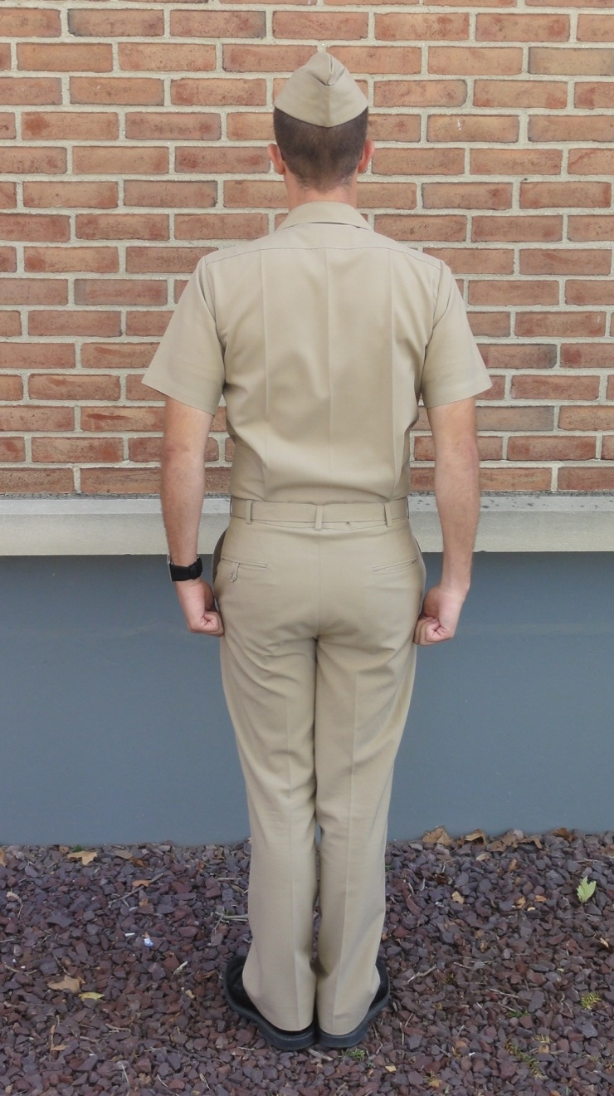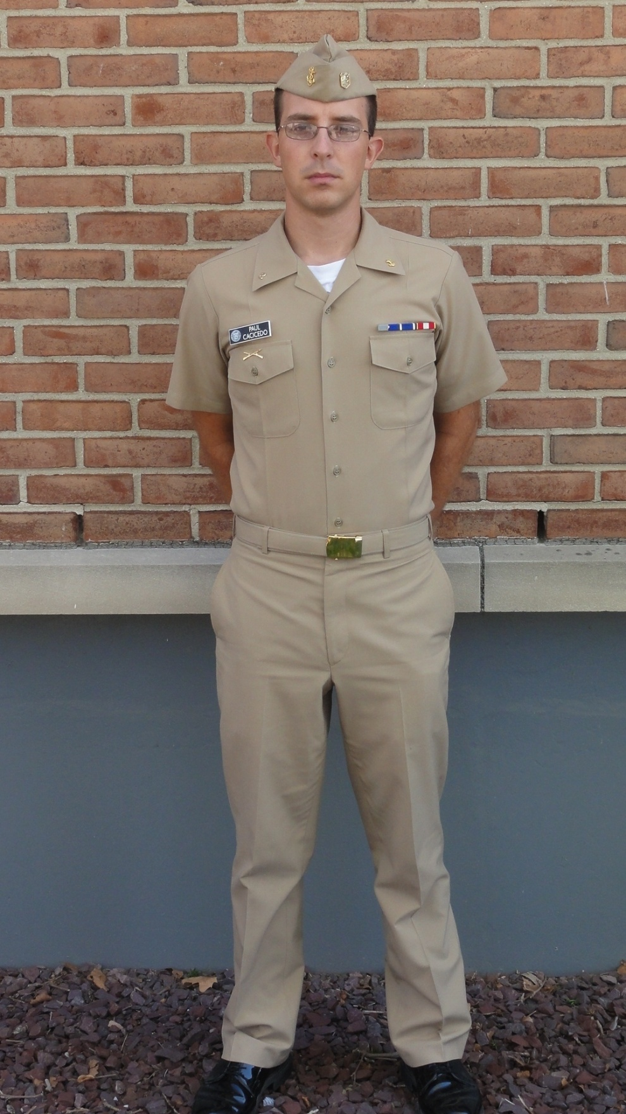

**UNIFORM PHOTOS**

**SUMMER WHITES**

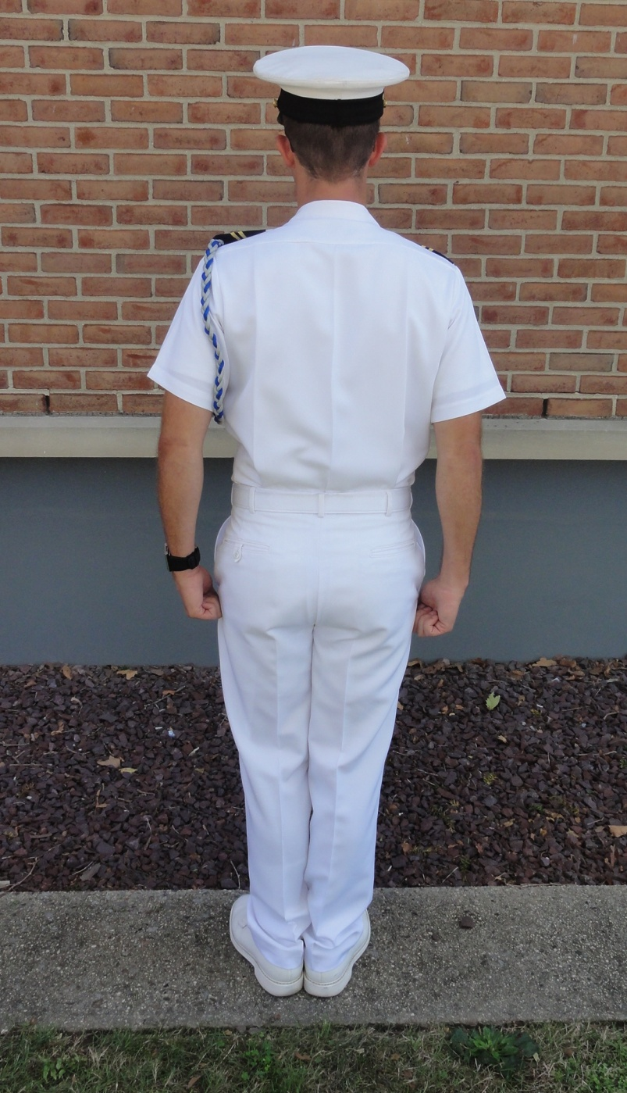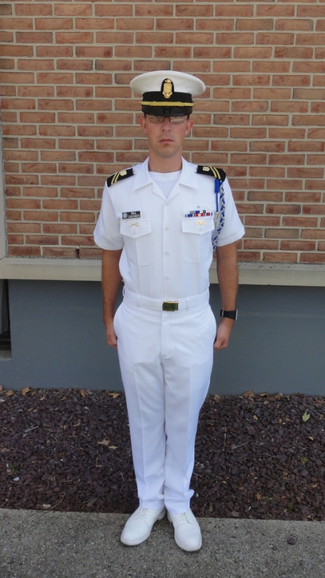

**UNIFORM PHOTOS**

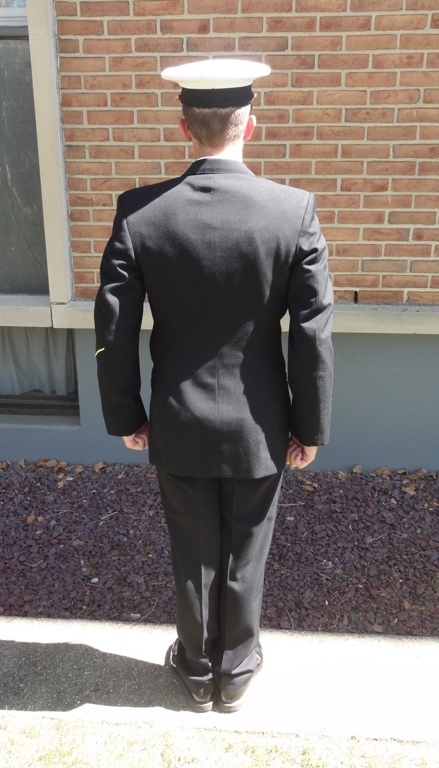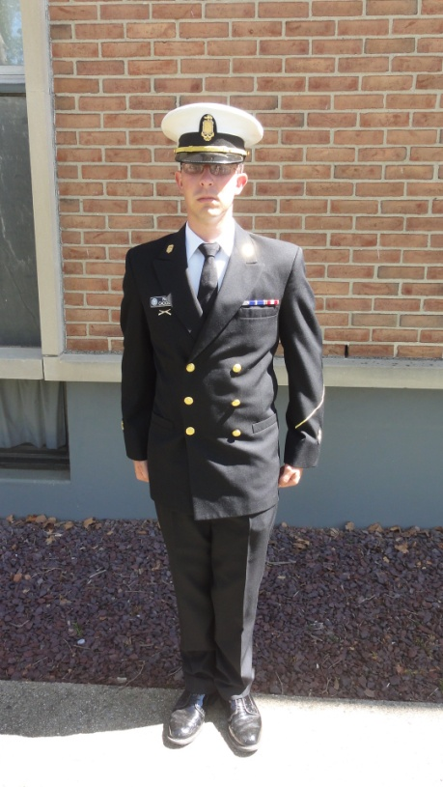**SERVICE DRESS BLUES**

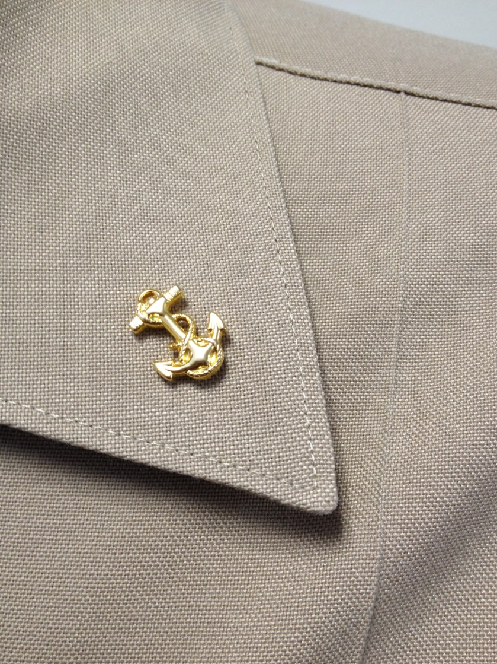

**1”**

**UNIFORM PHOTOS**

**BOILERSUIT**

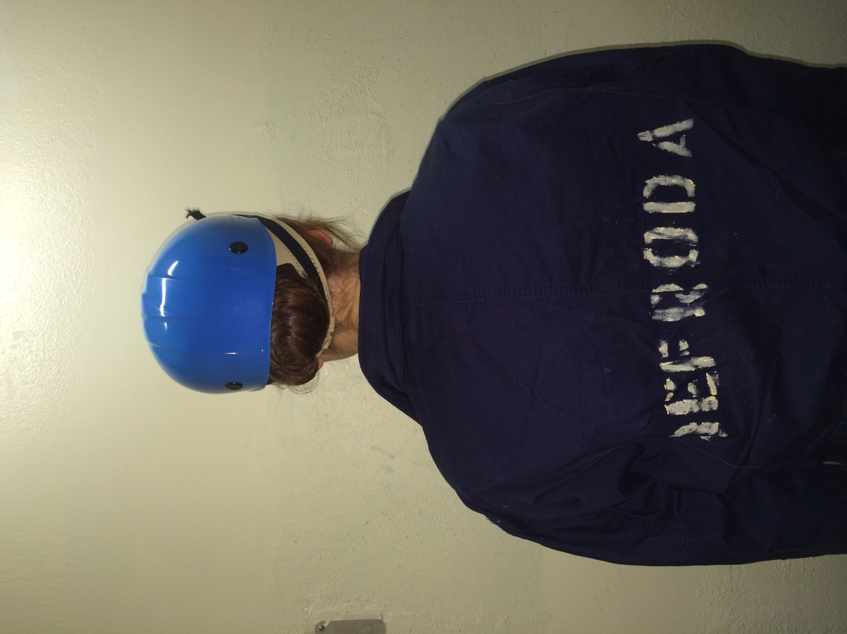

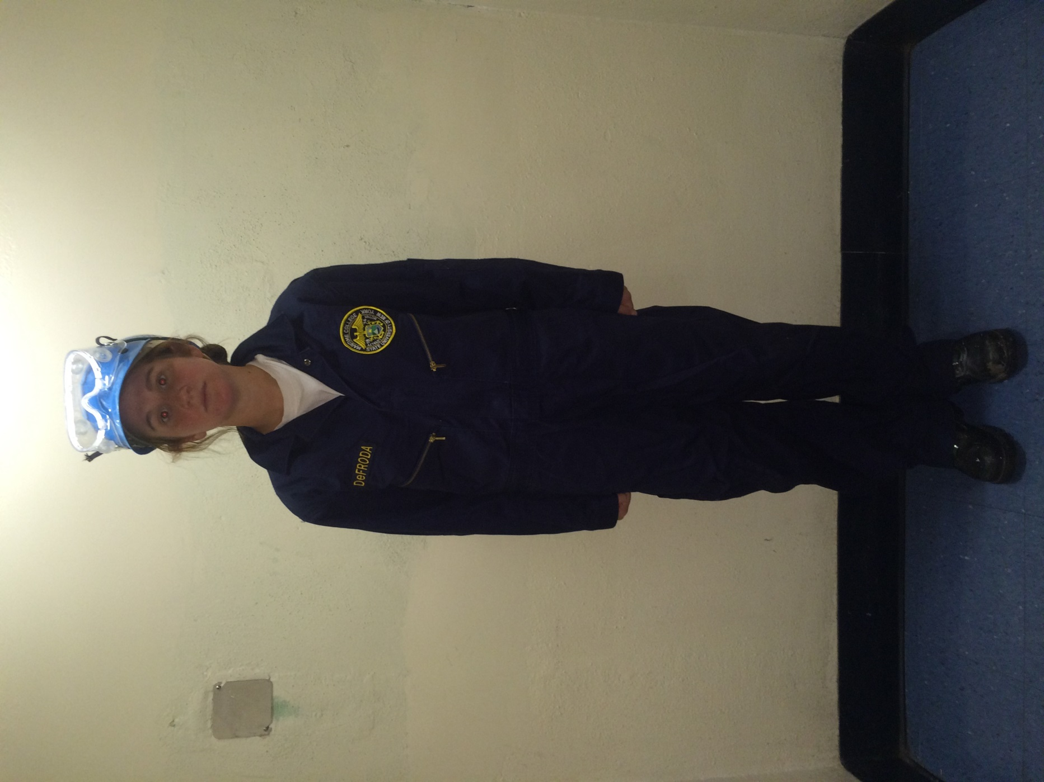

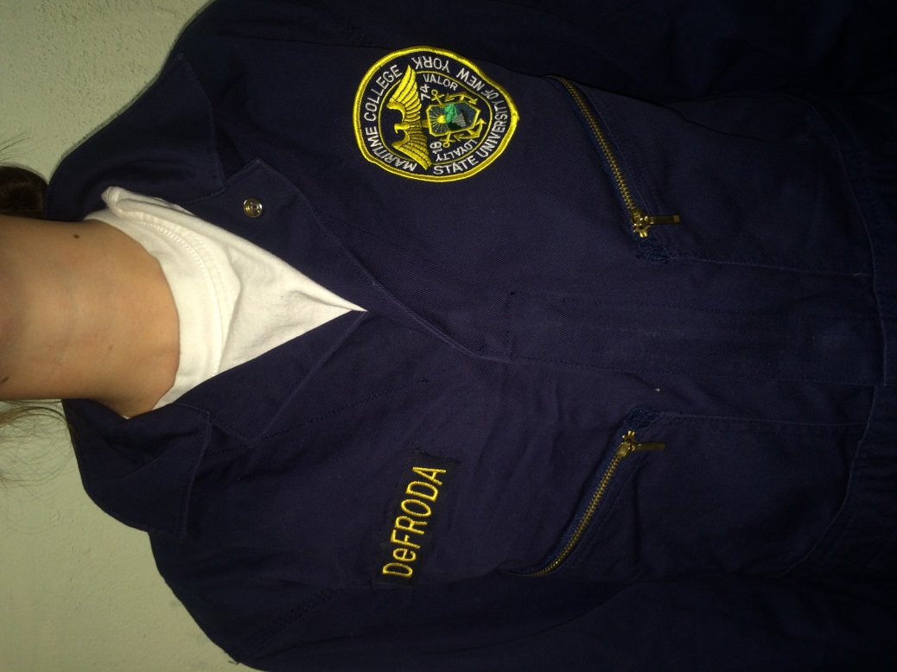

**UNIFORM PHOTOS**

**COVER DEVICE**

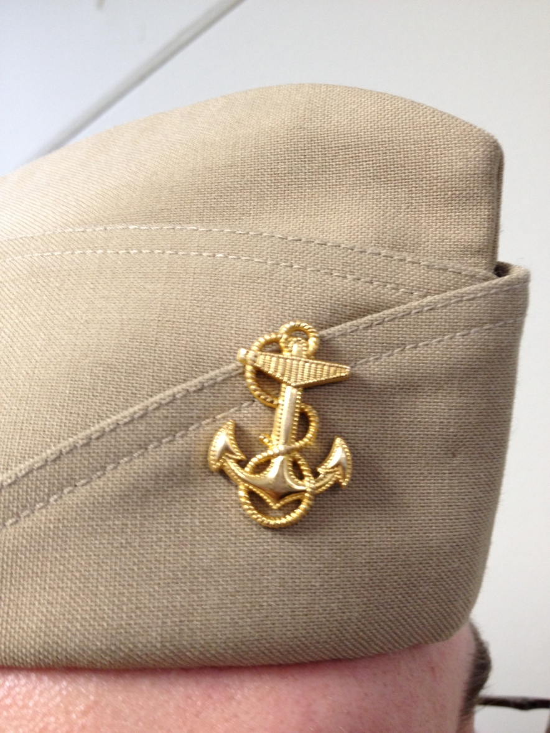

2”

1 ½”

**UNIFORM PHOTOS**

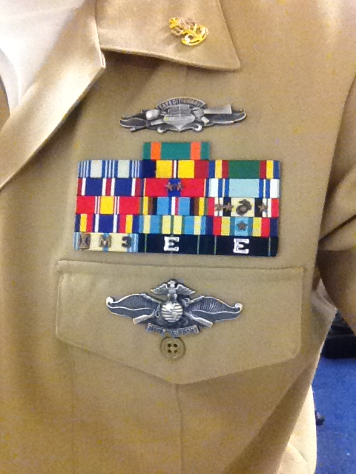**RIBBONS/BREAST INSIGNIA**

1/4”

1/4”

1/4”

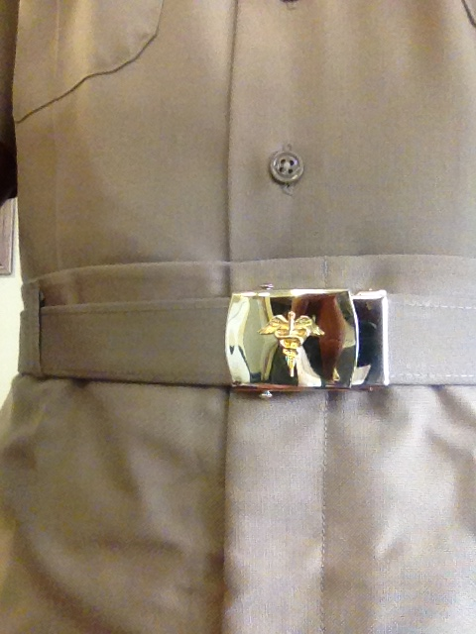**UNIFORM PHOTOS**

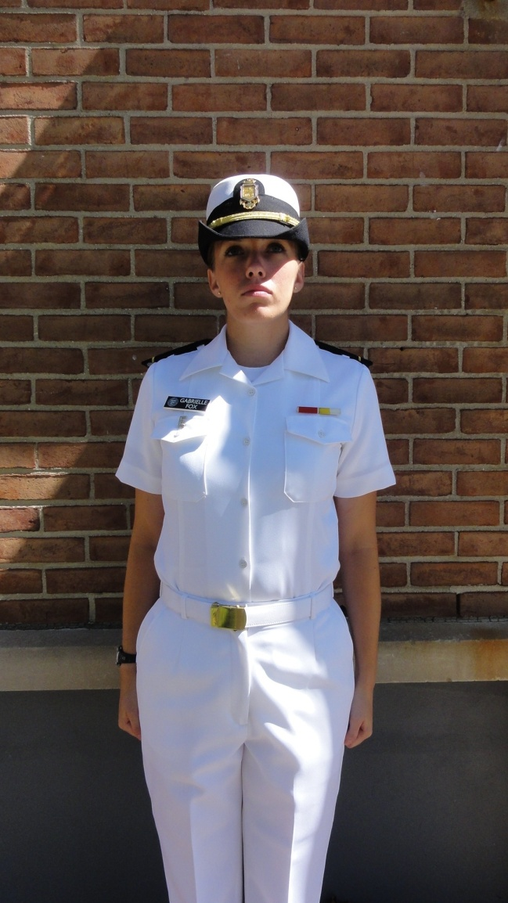**GIG LINE**

**Males Females (Reversed)**

**UNIFORM PHOTOS**

**GROOMING STANDARDS (MALES)**

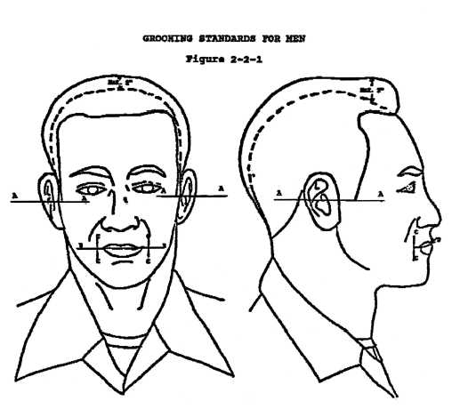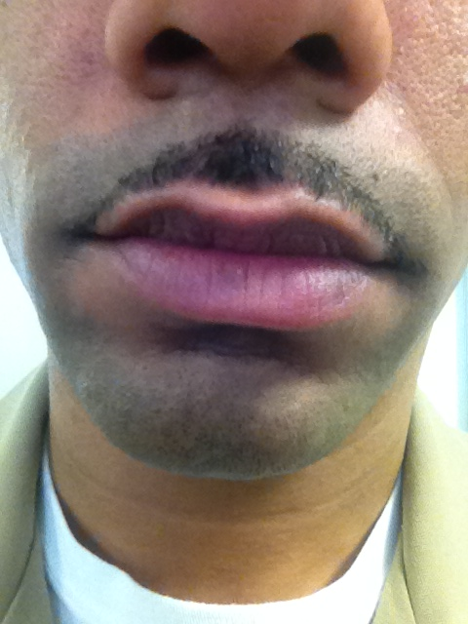

2”

1/4”

1/4”

**UNIFORM PHOTOS**

**GROOMING STANDARDS (FEMALES)**

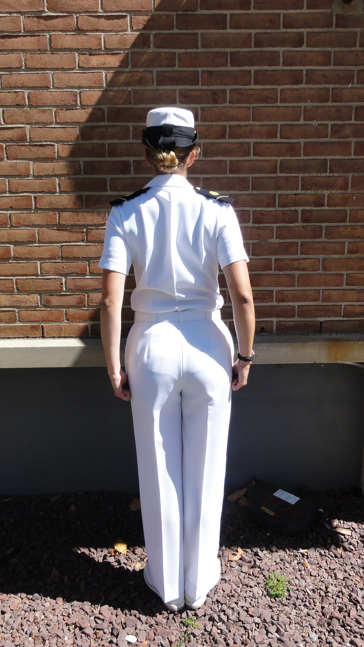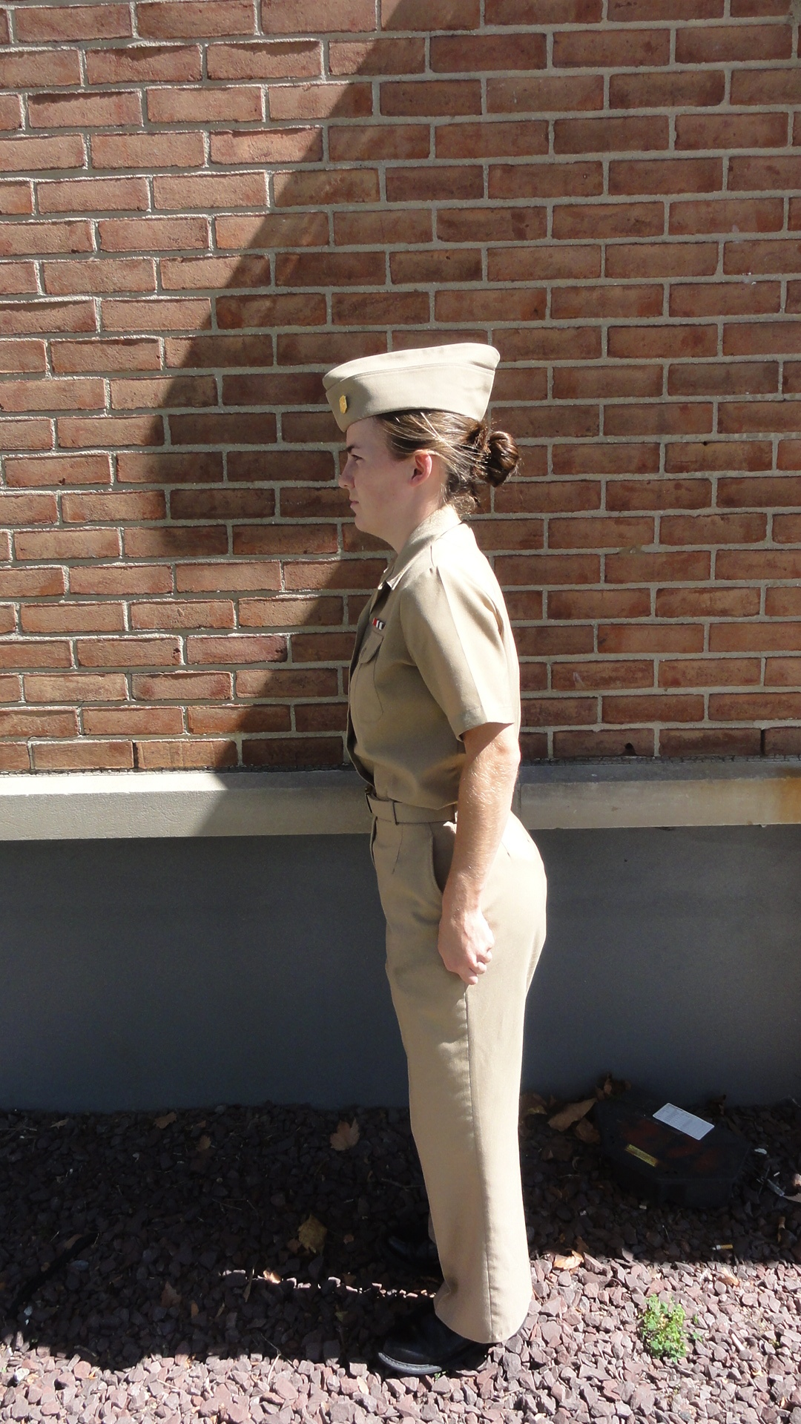

No hair below the bottom edge of the collar

No hair below the bottom edge of the collar

Tight Bun

Tight Bun